Shri Vile Parle Kelavani Mandal

Shri Bhagubhai Mafatlal Polytechnic

Vile Parle-(West), Mumbai-400056

ZeroWaste

Food Sharing App

Synopsis By:

Group No:11

Daanee Chheda (57498230023)

Heer Panchal (57498230030)

Jas Dudhat (57498230046)

Under Guidance of:

Mrs Radhika Patwardhan

**Contents:**

Abstract 3

Problem Statement 3

Introduction 3

System Requirement Specification 3

Hardware Requirements 3

Software Requirements 4

Proposed System 4

Features 4

Estimation and Planning 5

Diagrams 6

Use Case Diagrams: 6

Activity Diagram: 7

Flowchart: 8

DFD: 10

Future Scope 13

Conclusion 13

**Diagrams:**

Figure 1: Gantt Chart 5

Figure 2.1: Use Case Diagram 1 6

Figure 3: Activity Diagram 7

Figure 4: Flowchart-1 8

Figure 5:Flowchart-2 9

Figure 6:DFD Level-0 10

Figure 7:DFD Level-1 11

Figure 8:DFD Level-2 12

# Abstract

The **ZeroWaste** project is an initiative to minimize food wastage by connecting restaurants, individuals, and NGOs through a digital platform. Every day, large quantities of edible food are discarded by restaurants, events, and households, while many people go hungry. ZeroWaste aims to bridge this gap by creating a system where surplus food can be shared with those in need. The platform allows donors (restaurants, households) to post available surplus food and enables NGOs or volunteers to pick it up and distribute it to underprivileged communities, thereby promoting sustainability and social responsibility.

# Problem Statement

In urban areas, a significant amount of food is wasted daily, especially by restaurants, weddings, and households, while many people still struggle with hunger and malnutrition. There is no organized platform to coordinate surplus food donations and its timely distribution. This results in unnecessary waste and missed opportunities to help those in need. The **ZeroWaste** platform addresses this by providing a simple and efficient way to connect food donors with NGOs and volunteers, reducing food waste and contributing to hunger reduction.

# Introduction

Food waste is a major global issue. According to recent studies, around one-third of the food produced globally is wasted. In India, despite food surplus in some areas, millions still sleep hungry. This project, **ZeroWaste**, is inspired by the need for a scalable solution to redistribute excess food before it gets wasted. This platform acts as a mediator where food donors can list excess food, and nearby NGOs are notified to collect and distribute the food. Features like real-time notifications, geolocation enhance efficiency and accountability. The goal is to make food redistribution easier, faster, and more reliable.

# System Requirement Specification

Hardware Requirements

Server:

Processor: 2.0 GHz or higher

RAM: 8 GB or more

Disk Space: 200 GB SSD or more

Client:

Processor:1.6 GHz CPU or more

Memory: 2GB RAM or more

Disk Space: 40GB or more

Software Requirements

Server:

OS: Windows / macOS

Backend: Flutter / Node.js

Web Server: Firebase Hosting

Database: Firebase

Others: OpenAI API, Google Maps API

Client:

OS: Android 8.0+ / iOS 13+

Browser (for Admin): Chrome / Firefox / Edge

# Proposed System

Our project will be able to manage surplus food listings, NGO coordination, volunteer delivery tracking, and maintain a detailed record of donations and food waste reduction. The software will automate the entire food redistribution process with minimal human intervention. Automating food rescue operations will improve efficiency and promote communication between donors and NGOs. It minimizes the time taken to connect food donors with NGOs by providing a seamless interface, allowing users to focus entirely on reducing food waste and feeding the needy.

This system will handle the creation of food posts by restaurants or individuals, real-time notifications to nearby NGOs or volunteers, and assign tasks based on availability and proximity (within a 5km radius). A verification system ensures the safety and trustworthiness of all participating parties. This transparent system will help build trust among stakeholders and allow better decision-making.

The platform will improve social engagement by allowing users to give feedback and view their contribution metrics such as meals saved and carbon footprint reduced. Our portal will serve as the interface between donors and NGOs.

# Features

### **Features of ZeroWaste App**

1. **Login Page:**
   * Login and signup options for:
     + Restaurants
     + NGOs
2. **Food Listing & Sharing:**
   * Restaurants can list surplus food.
   * Add details like:
     + Type of food
     + Quantity
     + Location
3. **NGO Matching:**
   * System finds nearby NGOs for restaurants based on location.
4. **Real-Time Notification:**
   * Instant alerts for:
     + New food listings
     + Reminders for food nearing expiry
5. **5 Km Radius Condition:**
   * Food pickup is limited to a 5 km range for efficient delivery.
6. **Track Food Saved:**
   * System tracks how much food has been saved through donations.
7. **Feedback System:**
   * Quality feedback loop from NGOs to ensure:
     + Food safety
     + Hygiene standards
8. **Awareness Section:**
   * Informative articles on:
     + Food sustainability
     + Waste reduction tips
9. **User Verification:**
   * Approval process for:
     + Registered NGOs
     + Restaurants (for verification and trust)

# Estimation and Planning

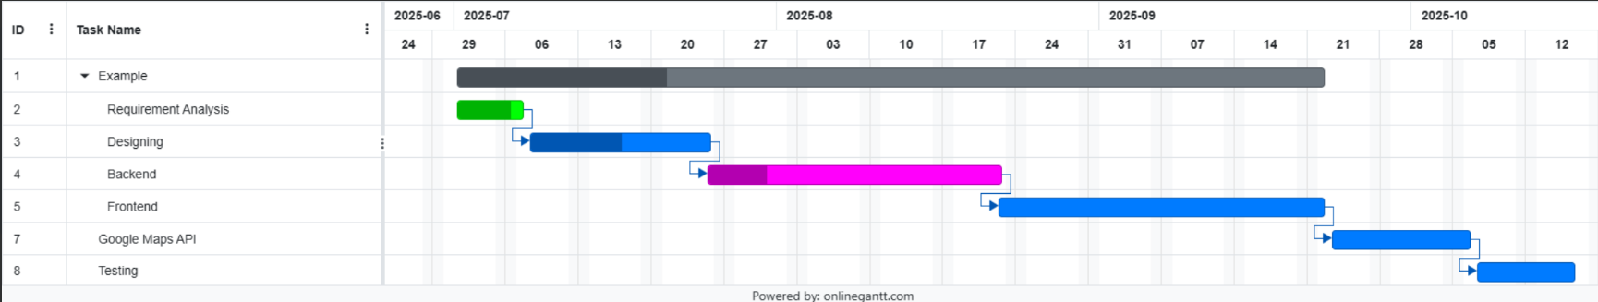

Figure 1: Gant Chart

# Diagrams

## Use Case Diagrams:

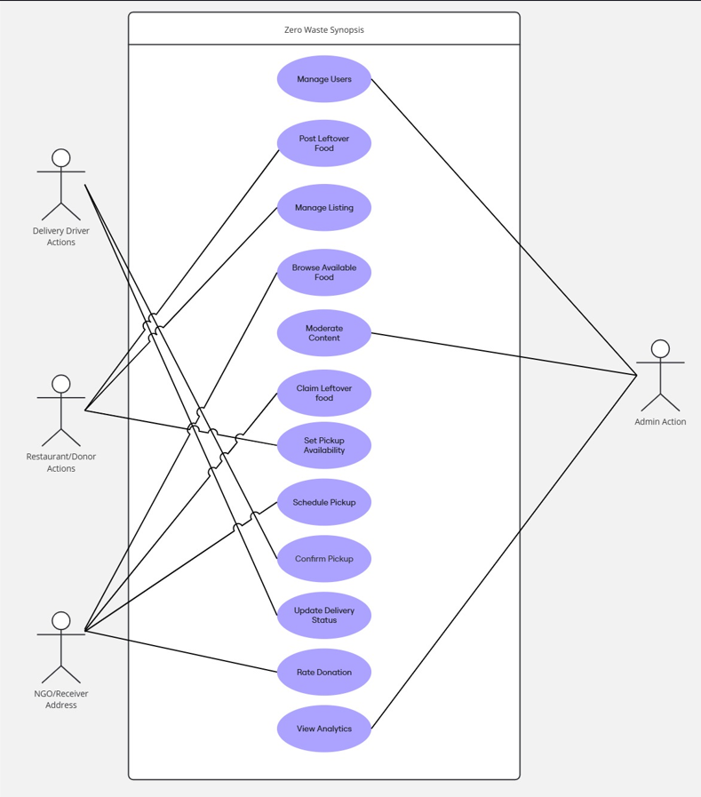

Figure 2.1: Use Case Diagram 1

Activity Diagram:

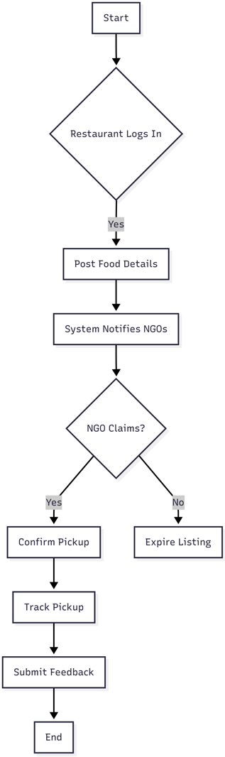

Figure3: Activity Diagram

Flowchart :(Restaurant)

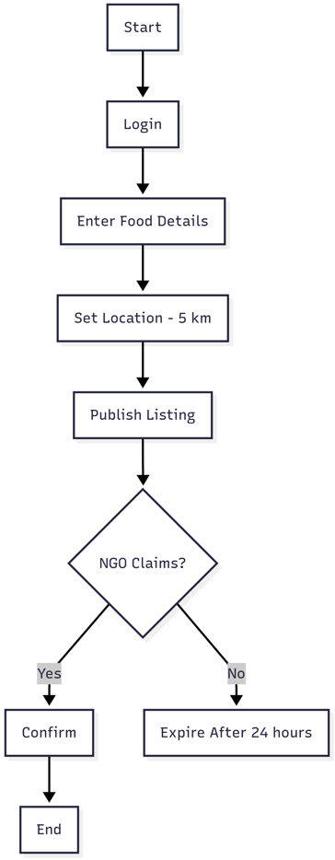

Figure 4: Flowchart-1

Flowchart:(NGO)

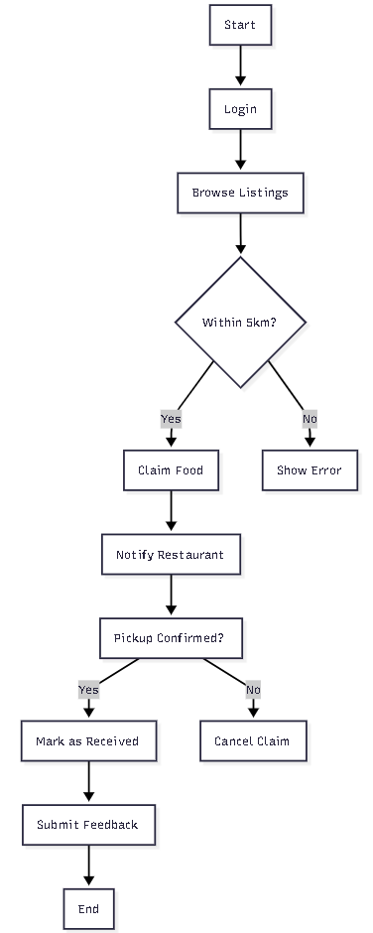

Figure 5:Flowchart-2

## DFD Level 0:

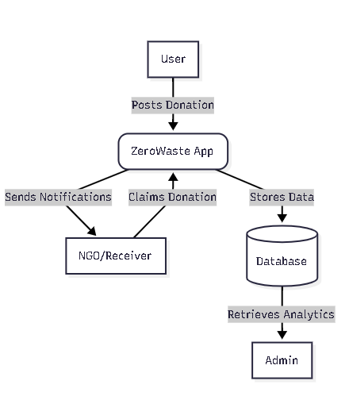

Figure 6:DFD Level 0

## DFD Level 1:

## 

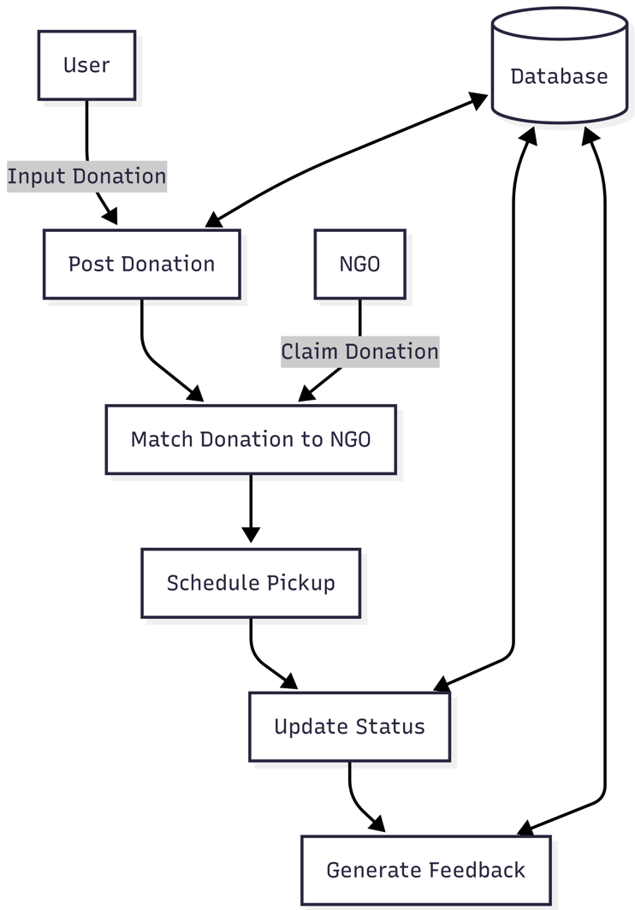

Figure 7:DFD Level 1

## DFD Level 2:

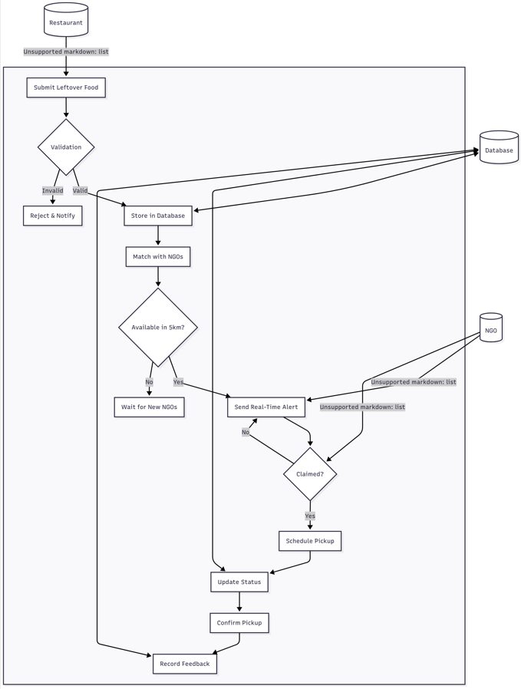

Figure 8:DFD Level 2

# Future Scope

* The app can support more cities, towns, and rural areas.
* The app can be linked with government or NGO databases for easier verification.
* Expand awareness section with articles, success stories, and food-saving tips.
* Integrate social media sharing to spread awareness and app promotion.

# Conclusion

The ZeroWaste platform is a helpful and impactful solution for connecting food donors with NGOs, ensuring that surplus food reaches those in need. It streamlines the process of food sharing and enhances communication between restaurants and NGOs. The platform supports efficient food listing, real-time tracking, and timely distribution, reducing the burden of manual coordination. It promotes transparency and trust by allowing verified users and feedback mechanisms, leading to safer and more reliable food donations. With its user-friendly interface and social focus, the app increases participation and builds a strong, responsible community. In today's world, it is essential to use technology not just for productivity but also to address real-world problems — and ZeroWaste serves as a powerful tool to reduce hunger, prevent food waste, and support sustainability.